Homework 2

CS 558

Author: Zhenyue Liu

# **1. Procedure**

a. Read image ‘road.png’

b. Pre-processing

- Use Gaussian filter to smooth the image

- Use Sobel filter to get the direction

- Apply Hessian detector. In order to get second order derivative of image along xx, yy, xy direction, I apply Sobel filter as derivative operator first order derivative of image along x and y axis, and do it again to get the result. Set threshold to be 400.

- Apply non-maximum suppression by a matrix with 1-pixel half width, and get the interest points

- Manually eliminate the noise interest point on trees and ground

- Display the interest points

c. RANSAC

- Initialize N and sample_count as 1 and 0, iterate the RANSAC loop till N ≤ sample_count

- In the loop, first randomly choose two points, then compute distance of all other interest points to the line formed by two chosen points.

- Threshold the distance to get the number of inliers, and compute outlier ratio

- If outlier ratio is the smallest(number of inlier is the largest), store inliers, and recompute N

- Use inliers to generate a line

- Eliminate the inliers used to draw a line

- Repeat four times to draw four lines

d. Hough Transform

- Transform n interest points into Hough parameter space, and we get n lines

- Threshold the votes and find the top 20 ones in Hough matrix

- Transform the points in Hough matrix back to original image space, and get 20 line

- Choose the best four lines as output

# **2. Output**

a. Interest points

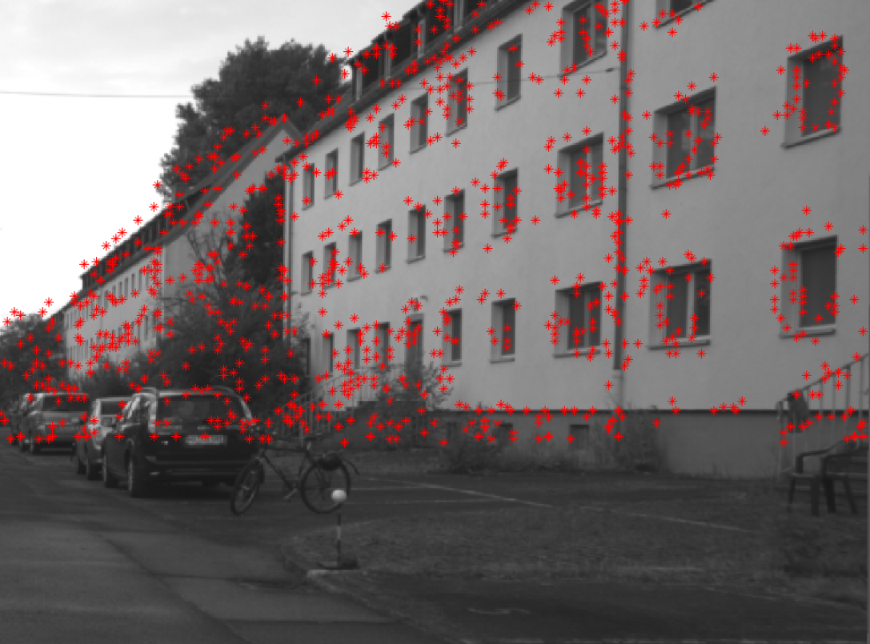

b. RANSAC

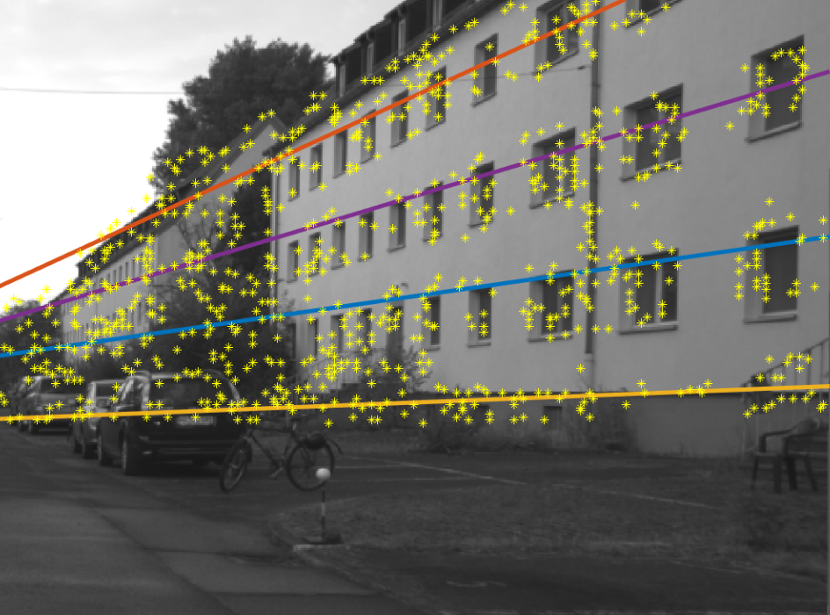

c. Hough

